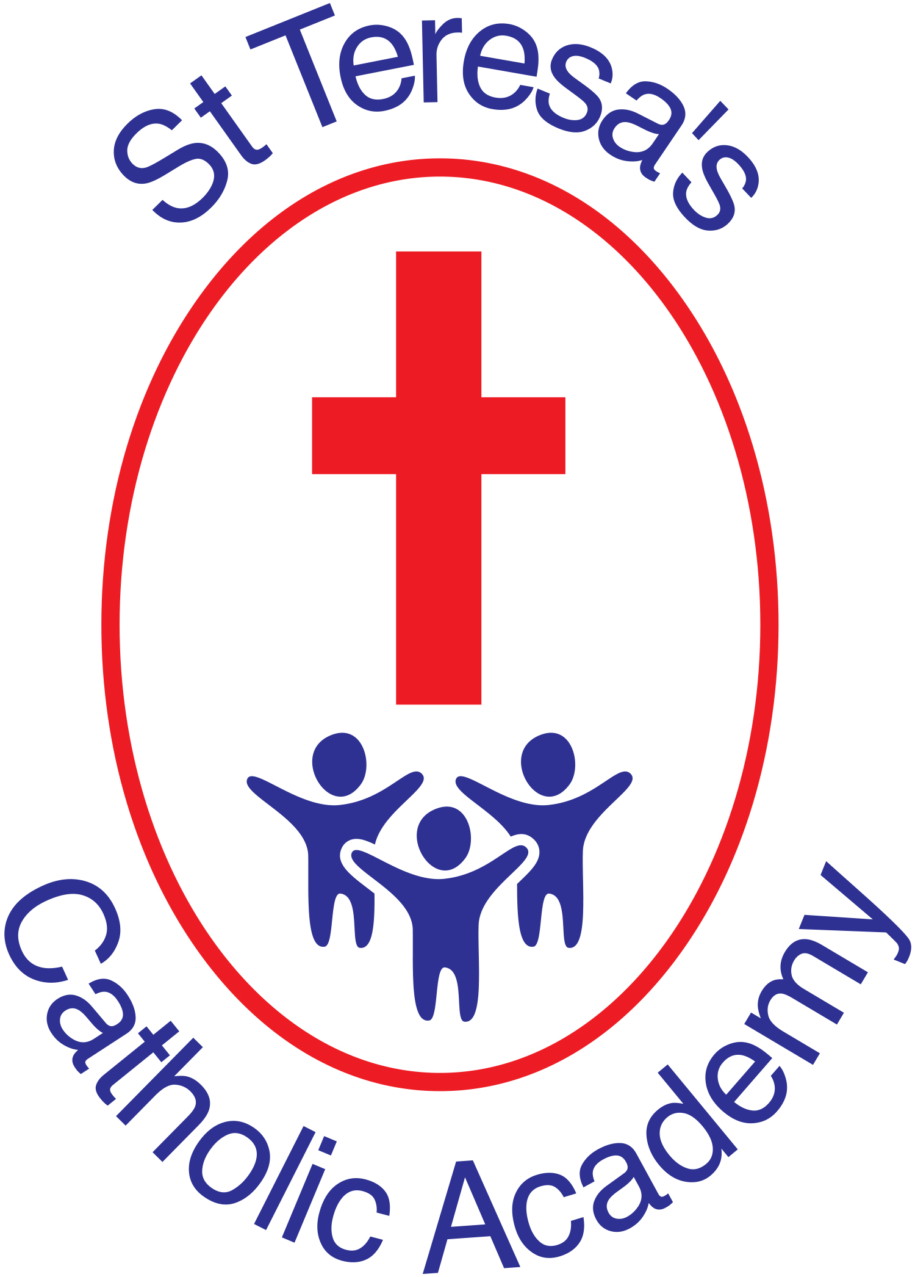
St Teresa’s Catholic Academy
Year 5/6
Autumn 2020

Ancient Greece

DT/Art
Q. How do artists capture images of Ancient Greek battles?
Q. What can we learn about Greek life from their pottery?
Q. What sculpting techniques are used with pottery clay?
Q. What was Ancient Greek architecture like?
Q. How did the Greeks decorate their homes?
Q. Why and how did Greeks create mosaics?
Q. What did Greek temples look like? How were they designed?

Science

Electricity:
To use scientific equipment safely.
To use symbols accurately when representing a simple circuit in a diagram.
To be able to carry out a fair test and record the results reliably.
To be able to compare and give reasons for variations in how components function.
To design and make an electrical scarecrow.
To explore renewable sources as an energy source.
To compare UK energy data over time, in particular the use of renewable energy sources.
To investigate static electricity.
English

Year 5
Here We Are
Medusa
Greek Myths
Poetry – The Dog with the Luminous Nose & Russian Doll
Oliver Twist

Year 6
Medusa
Dulce et Decorum Est
The Call
Francis Brandywine
The Woman in White
The Ghastly Waxwork
If I were a toy…
Computing
Year 5:
Microsoft Teams
eSafety
Coding - Microbit

Year 6:
Microsoft Teams
eSafety

PE
Q. Which events took place in the Ancient Olympic Games?

Year 5:
Outdoor: Circuits

Year 6:
Outdoor: Athletics
History
Q. When was the Ancient Greek empire?
Q. What is the chronology of Ancient Greece?
Q. What was life like in Sparta and Athens?
Q. Why were Greeks successful in battle?
Q. What happened during the Greco-Persian wars?
Q. What are the origins of the Olympic Games?
Q. How does the Greek alphabet compare to the current English alphabet?
Q. Who was Alexander the Great?
Q. How does the Ancient Greek understanding of mathematics inform our current mathematics learning?

Music
Q. What Greek stories can we learn through music?

Geography
Q. Where is Greece?
Q. Why did people settle in Greece?

RE
Q. What did the Ancient Greeks believe?

